Sliding Door Replacement

There are quite a few options to replace the black lexan sliding doors in Mark l cabins when they inevitably crack near the handles. Choosing the simplest approach, we removed the old doors by placing a small jack in the middle of the shelf and carefully lifting the top shelf just enough to remove the old doors. Using the old doors as a pattern, we cut new 1/8” thick teak plywood doors.

The 1/8” ply fits nicely into the existing groove. It would be practical to rout the edge of thicker material (up to ¼”) to accomplish the same thing. We then replaced the stock handles with larger wooden handles that also serve as a door stop. The photo shows the doors installed in our cabin. Our 1988 boat has oiled teak, which tends to be darker than varnished teak but is ruthlessly simple to repair!

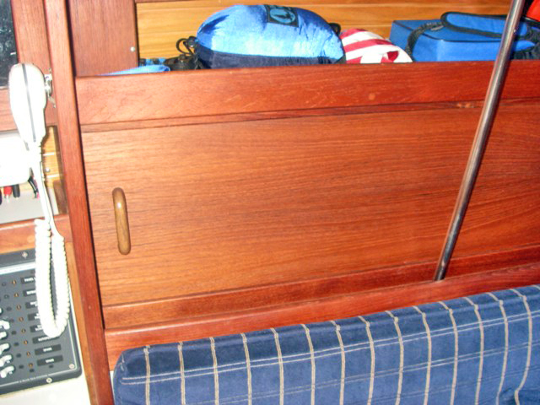Title- Replaced sliding doors

Mike Vaccaro, “Spirit,” 1988 Hull 563

