Modifying a Garhauer Lift

The Garhauer lift is a great “back saving” piece of equipment to have onboard. However, if you have to mount it close to a Bimini, it’s difficult to operate the control line. The cam cleat on the lift (early versions) is usually higher than the Bimini rail making it hard to get at and disengage the line from that cam cleat!!

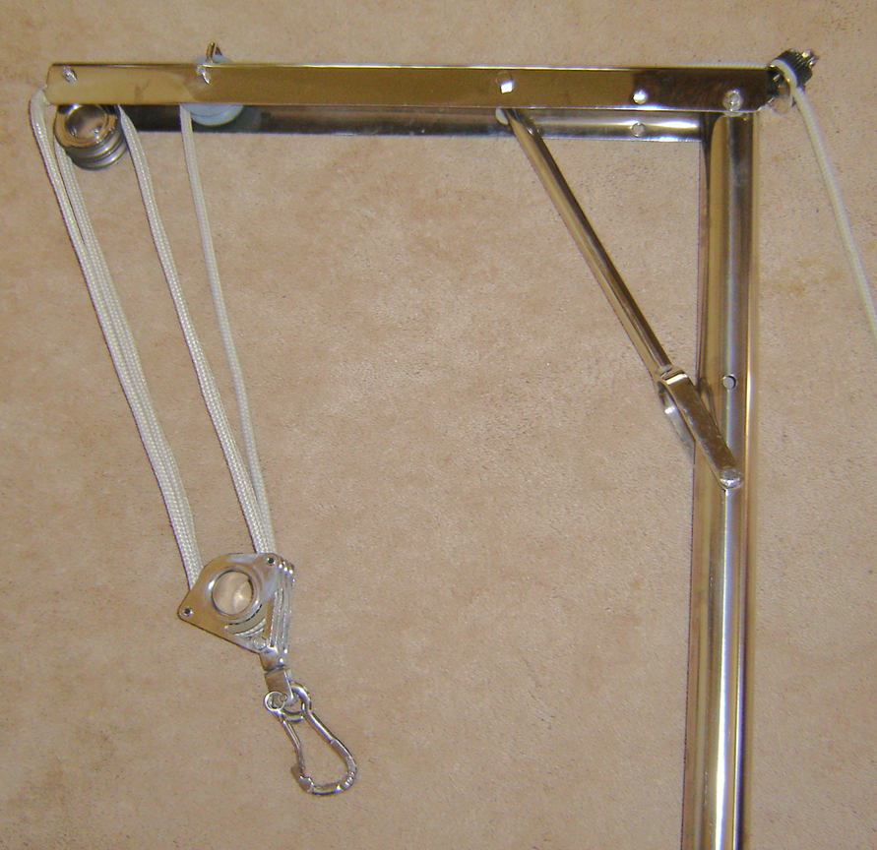

Garhauer Lift

I moved the cam cleat (w/eye strap) to a position lower on the upper tubular section of the lift, so it was easily accessible with my Bimini up. In its place, I mounted an eye strap (1 ½” hole centers) on a piece of 5/16” Lexan in the same position as the old cam cleat. I matched the bolt threads and used the factory threaded holes to mount it in place. I put the eye strap on the Lexan pad to give it added height so the line couldn’t rub against the stainless steel on that 90 degree bend. You can also use a “bullseye” fairlead instead of an eye strap and skip the Lexan pad. What you’re really looking for is a protected “guide” for the line to go through.

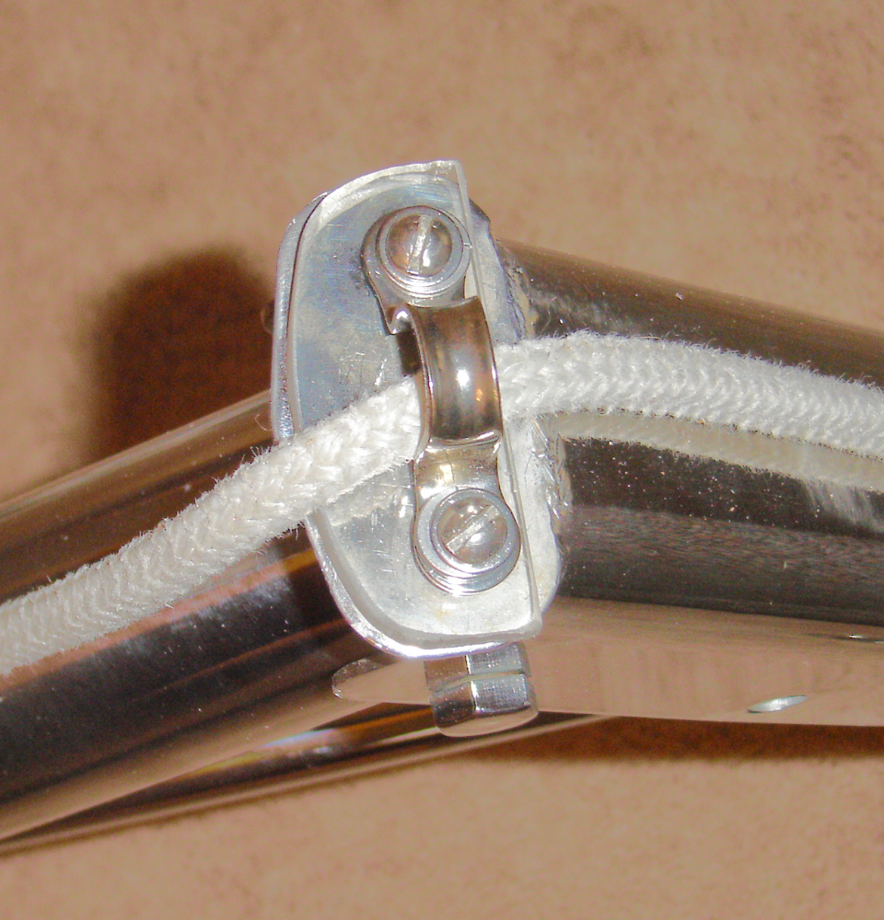
Eye Strap Mounted

Next, I cut another piece of Lexan to mount the cam cleat (w/eye strap) on. That piece of Lexan had to be larger in size (than the cam cleat) so it could be mounted on the upper tube. I drilled & taped two holes in the upper tube. Then I mounted the Lexan to the tube and the cam cleat to the Lexan.

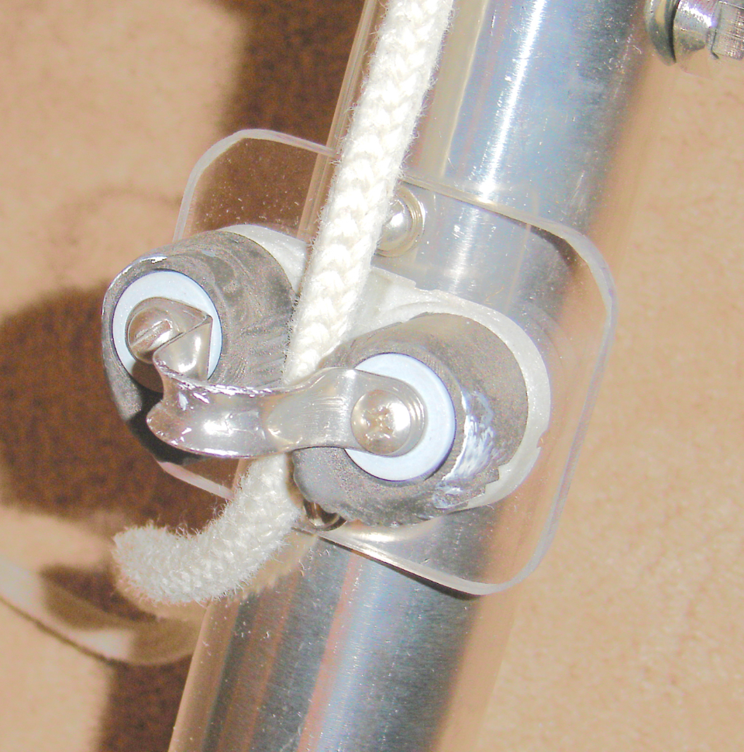 Re Mounted Cam Cleat

My total cost was about $2+ for the new eye strap, as I used leftover nuts, bolts and washers from other projects. I used Lexan (polycarbonate), but you could use a piece of sturdy aluminum or stainless for the new mounting pad. Just don’t use acrylic as it’s too brittle and will crack.

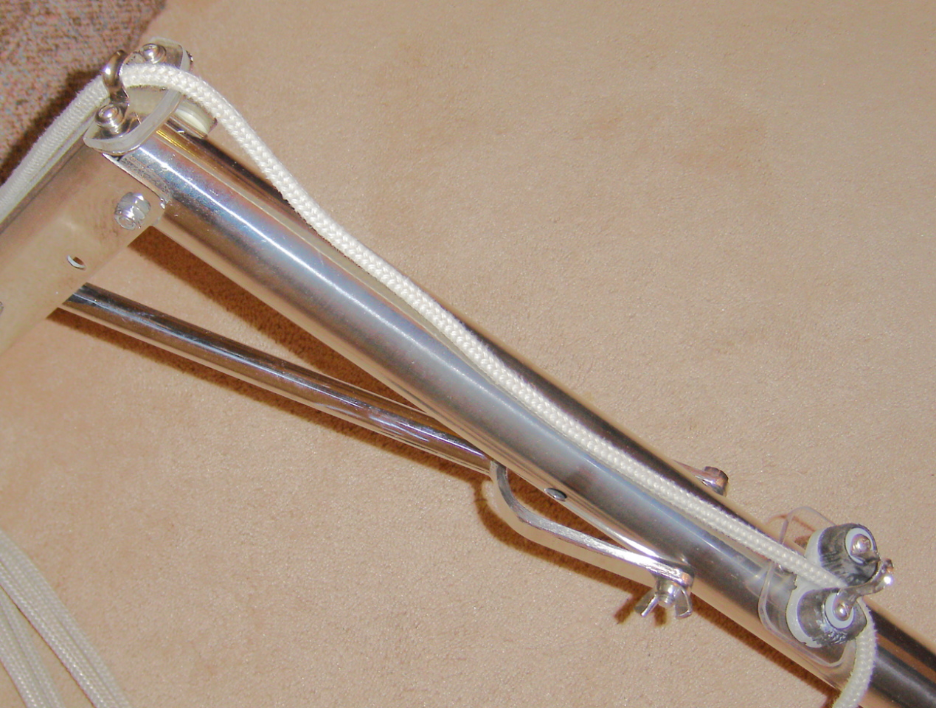

Finished Lift

Re-thread the lift line and you’re “good to go”! It’s easy to do and the entire project took less than 2 hours. Now I can get at the hoist line cam cleat easily and not have to do body contortions around the Bimini frame.

Ron Hill APACHE #788

