It's Been How Long?

One important facet of maintenance is to keep track of what and when work is accomplished. The easiest way to do this is to maintain some type of log. For repetitive tasks, it's best if you not only note when work is complete, but when a repeat is due. Likely, you'll be surprised at how quickly a year can pass, especially if you live in a location where your boat is in the water year-round. If you don't keep your boat in the water year-round, the commission/decommission cycle provides a good means of performing routine, preventative maintenance.

Most folks change their oil at 50-hour intervals or 12 months, whichever occurs first. When the oil is changed, it's a good practice to write the date and engine time right on the new filter so you'll see it each time you visually inspect the engine. It's also a good idea to compute the time and date the next oil change is due and make a note in the log.

In the case of motor oil, there are two things that will contribute to premature wear: ingesting dirt and acid build-up. Oil changes are the key to minimizing the impact of either of these. Fortunately, we operate our boats in an environment that provides a fairly clean air supply, but many of us are guilty of running the auxiliary for very short periods of time at low power. If the oil is not allowed to get hot enough, water that is formed during combustion can accumulate in the oil and will combine with other byproducts (e.g., sulfur) and produce acids that can accelerate internal engine wear. If your engine is run infrequently or for short periods, it's important to change the oil more frequently than if it's run for at least 20 minutes developing power on a regular basis. If your engine is run only occasionally, consider changing your oil every four to six months. The bottom line is that frequent oil changes are one of the best ways to ensure that you'll get as much (or even more!) than 5,000 hours out of your auxiliary.

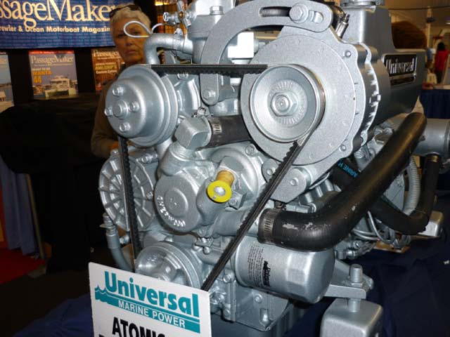
Title "M35 engine oil filter & impeller"

There have been quite a few articles regarding HOW to change the oil, but one of the best inexpensive modifications you can make is to install an elbow fitting in the oil drain with a line that allows you to easily attach a pump to drain the oil. Don't forget Ron Hill's technique of cutting a small Tupperware -type container to cover the motor mount underneath the filter to minimize the chance of spilling oil on the rubber motor mount (rubber and petroleum products don't always get along). Another option is to drive a pick or long (120) drill bit through the filter from the top down to allow the oil to drain into a small container before you un-spin it.

Along with regular lubrication of your running gear and control cables, four other areas around the engine also merit regular attention: changing the anti-freeze at two-year (or less) intervals; keeping the heat exchanger clean and zinc in good shape; monitoring the condition of the raw-water impeller and checking for leaks; and checking the condition of the exhaust riser.

Anti-freeze is usually overlooked in boats based in warm-weather climates, but since it flows around the INSIDE of the engine, it's another inexpensive bit of regular maintenance that can pay big dividends. In addition to changing coolant at regular intervals, we also flush our system by filling with distilled water, allowing the engine to run at operating temperature, then draining the distilled water and replacing with fresh anti-freeze. Quite a few brands of anti-freeze are now sold "pre-mixed," so be sure to read the label carefully so that you don't accidentally dilute the mixture.

Heat exchanger zincs don't last long in warm, salt water! If you operate in salt water, you should check the zinc at four month intervals. If more than 50% of the zinc remains intact, it can be reused. However, it's just as easy to CHANGE the zinc as it is to CHECK the zinc. It's your boat/your choice, but the small cost of a pencil zinc is probably not an area that you want to try to save money! Don't use Teflon tape on the brass zinc fitting, as metal to metal contact is required for the zinc to work as advertised. A non-hardening gasket material (Permatex Type 2, etc.) can be used to prevent seepage.

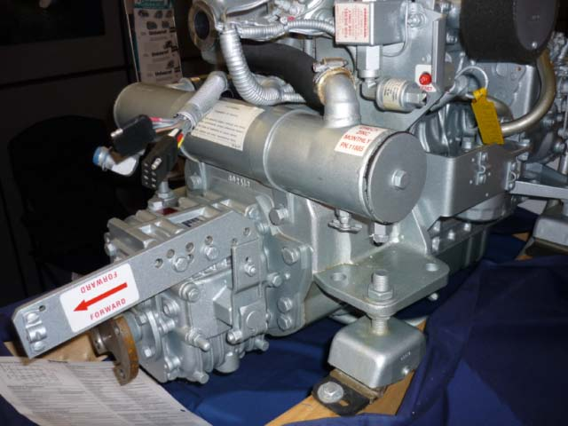
Title "M35 engine heat exchanger"

The only way to properly clean the exchanger is to remove it from the boat. After the end plates and gaskets are removed, the exchanger can be cleaned at home using an acid solution (Lime Away, On & Off, CLR, etc.) or can be sent to a local radiator shop to be boiled out. There is no specific interval for cleaning the exchanger - it depends on the environment you sail in, and how often the engine is run. Warm, salt water? Keep an eye on your temperature gauge. In 80+ degree water with a 160-degree thermostat, a clean 3-inch exchanger on an M-25 or -35 will keep the system temperature at 170-180 degrees. If it's been two years or your operating temperature is exceeding 180 degrees at cruise power settings, it's probably time to clean it (unless the ambient temperature is approaching 100 degrees). Cold, fresh water? Count your blessings!

The only way to check the condition of the impeller is to open the front cover of the pump. Be sure to throw some towels underneath, as you'll spill water when you do this. If it's salt water, it doesn't need to be spilled on your engine, accessories or mounts. If it is, be sure to rinse with plenty of fresh water. Unless there is an obvious crack or missing blade, it's tough to judge the condition of an impeller by simply looking at in the pump. Some folks change theirs based on time (1 or 2-year intervals), others install long-life impellers (e.g., Globe) and others simply run the engine until it fails, risking over-temping the motor and or a clogged cooling line or heat exchanger if a chunk of blade breaks off and is pumped downstream. If you are in the latter category, you might consider purchasing a "quick change" impeller cover kit, which will allow you to swap impellers in short order if one fails. If the inside of the cover is worn, it should be replaced or honed. If it's honed, it may be necessary to install lock washers underneath the mounting screws (or use shorter mounting screws) to ensure a tight seal on the gasket. A bad seal will prevent self-priming, which won't become apparent until you try to start the engine after sailing with the raw water sea cock open, usually about the time you need the engine to maneuver to the dock! The fastest way to damage an impeller is to forget to open the raw water intake when you start the engine. Many of us keep the key for the engine control panel hanging on the seacock or nearby when it's not in use, so it's tough to forget to open it!

The exhaust riser is something that most of us don't give much consideration to until it fails. All risers will eventually fail in some manner and require repair or replacement. How long that takes depends on what the riser is made out of (e.g., black iron, stainless, etc.) and what environment the boat is operated in (warm/cold/salt/fresh water). Again, a warm salt environment is the toughest on the riser. Typically, the riser will fail at the weld at the water injection point. But any riser can corrode and fail at any point. Most are covered with some sort of insulation, making visual inspection difficult or impossible. We completely remove our riser at two year intervals to inspect it. We replace the exhaust gasket and augment with high temperature RTV silicone each time we remove the riser. On our boat, we've left the area on the riser at the raw water injection tube un-insulated, so that we can visually inspect the joint each time we operate the sea cock.

The most "out-of-sight, out-of-mind" fluid in the auxiliary system is the transmission fluid. When the riser and heat exchanger are removed, access to the fluid fill point is quite good, the perfect time to pump out the old fluid and replace it. Read your engine manual to determine the type and quantity of fluid required; you'll be surprised by the small size of the sump!

Use the commissioning checklist in the owner's manual as a source for developing your own regular, preventative maintenance schedule. It's a lot easier to swap a bad impeller tied up at the dock, than it is when you're facing a foul current in a narrow channel and the water temperature gauge is starting to pass 200!

