Line-adjustable Genoa Cars Feb 2007

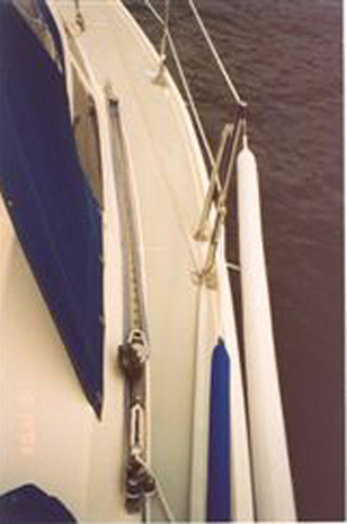
I replaced the old movable genoa car with Garhauer's new ball bearing cars -- MUCH better!!

Picture #1

You're going to have to remove 3 of the track screws and drive a small wedge under the track to get the system install on a early C34 with a recessed track. If you have a later C34 with a surface mounted track, then installation's a breeze! When you move the car forward you do have to be careful with the excess 5:1 car line as it can and will get caught with the Genoa sheet system.

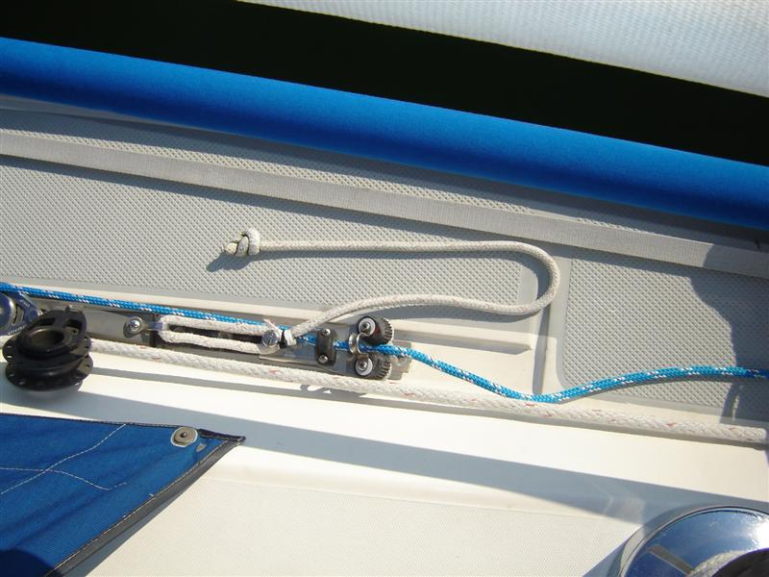
Picture #2

I looked at the bungee cord retract system and decided that it would only clutter the deck walkway. So I decided that the best way to pull the Genoa car back was with a tag line. I also have an 8" Schaefer stainless cleat mounted at the forward end of each track to act as a mid-ships cleat. Picture #2 gives a better blowup of how I put a "tag" line on the car to pull it back manually. I also used a longer screw headed bolt to secure the end of the loop to the stationary cam cleat section, so it stays in place while not in use. The threads of that screw have some protective hose on them so they can't chafe the tag line.

It sure beats having to go up forward having to pull a pin and fight the car forward, especially if there's wind in that genoa! Well worth the money for the ease of operation. Now when you "reef" the genoa it's now an easy task to reposition car for the best sheet line angle and sail trim.

Note: It's VERY important that when you order your movable Garhauer Genoa Car System that you specify that your C34 has or does not have a recessed track!!!

Ron Hill APACHE # 788

