Cockpit Showers

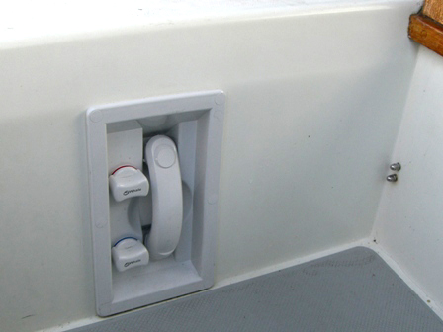

The simplest way to add a “shower” is to tee off a line from the head sink and run it up into the combing compartment underneath the port winch and attach a sink sprayer. This provides a ready source of fresh water in the cockpit for washing or rinsing off equipment or the cockpit.

Another option is to add a dedicated fixture—this is a plus if hot water is required in your locale. I ran across a neat installation by Steve Dolling in his 1988 Mark 1. The unit they installed is built by Whale and doesn’t have a door. Other “stow away” units are available with a door for about $125 to $150 from major chandleries.

The unit in the photo is in the forward end of the Lazarette, allowing for a short plumbing run from the hot and cold lines under the sink in the head. Although it would require a longer plumbing run, another accessible location in the closed-transom Mark 1 would be on the forward bulkhead underneath the helm seat. The more forward location that Steve chose has the advantage of having plenty of adjacent floor space for showering.

