Beckson Port Replacement Feb 2007

In July 2006 I was sailing along on port tack when I went below and noticed a huge gush of water coming in the forward port Beckson port in the V berth. The bedding was soaked and water was sloshing around over the floorboards. I found that one of the two dogs holding the latches had simply disintegrated. I stuffed a towel in the opening, and completed a great day of sailing.

I ordered a replacement port from Beckson and used the wooden tool described and pictured in FAQ section of the C34 Website: http://www.c34.org/faq-pages/faq-leakyports.html. The sketch shows the tool. I recommend adding big fender washers between the heads of the bolts on the outside and the nuts and the wood on the inside. These will avoid having the bolts and nuts dig into the wood and make tightening the tool much easier.

The Pictures show the work and what the tool looks like. This tool is very useful for those with older boats that will eventually have to replace the Beckson ports. I built the tool in 1999 and have replaced the two V berth ports and one in the salon. Three out of eight, so far! I used silicone sealant which has worked well with the earlier replacements.

The FAQ section of the website contains an invaluable amount of information about all of our boats, including the Mark IIs. I encourage you to review the contents and pick up a lot of good tips and tricks.

004 dog – shows the broken dog on the port
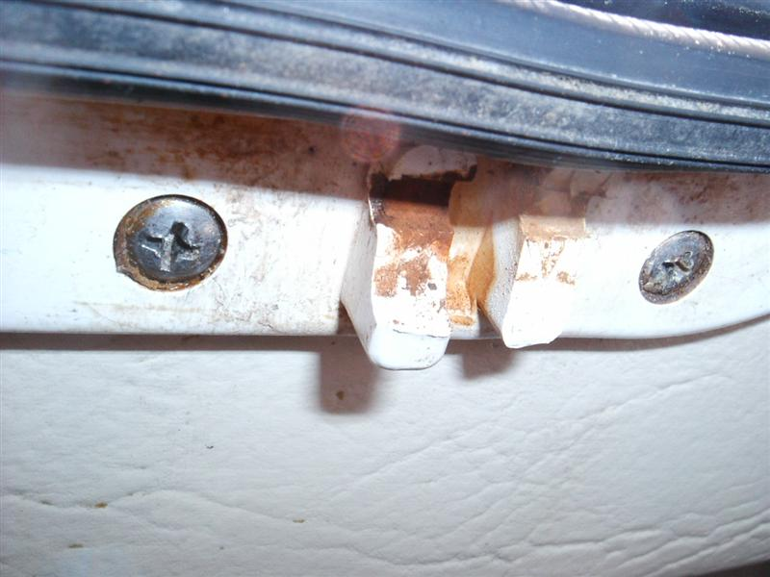

008 assembly – shows the wooden tool in place, note the big spacer between the inside of the cabin and the inside of the port, per the sketch on the website

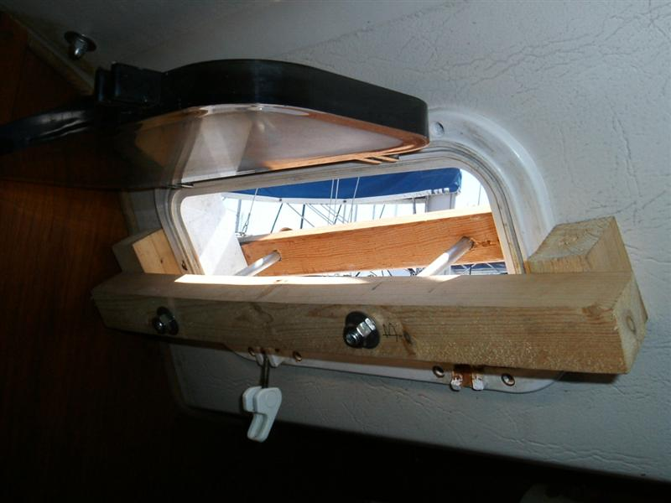

011 moving – shows the top of the port starting to come off the cabin liner – be sure to do this sloooowly as you tighten the nuts

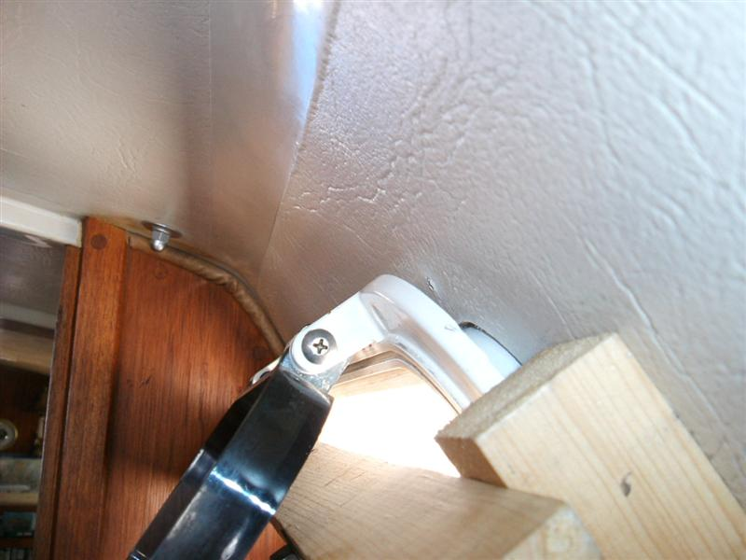

014 and 015 sealant 1 & 2 – shows the relative lack of sealant installed by the factory

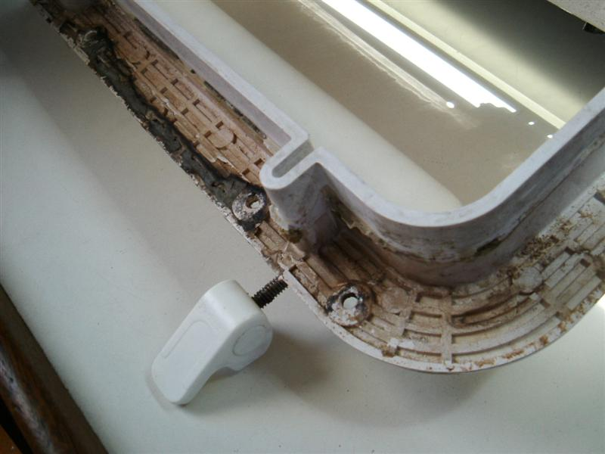

015 shows the relative lack of sealant installed by the factory

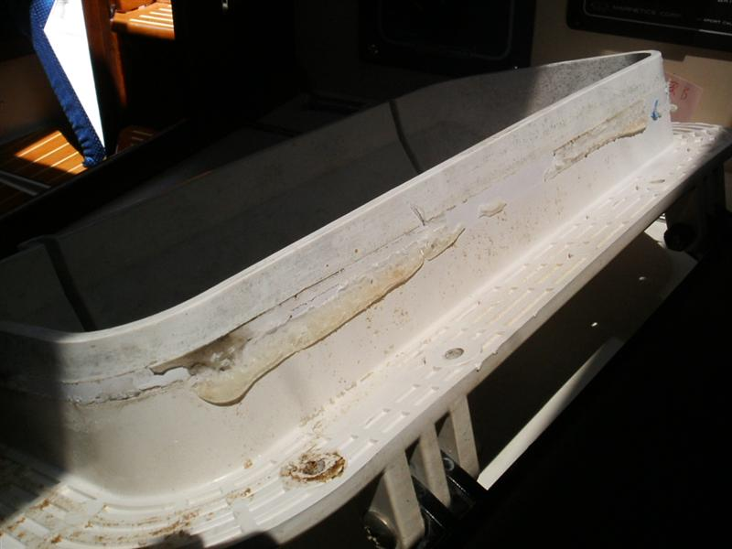

017 void – shows the gap between the cabin liner and the outside of the cabin top; the other side was fine with no gap; once tightened up the new port covered this gap

