Aft Cabin Replacement Ports

There have been several good articles about port replacement on our association website over the past couple of decades and in Tech Notes as well. Recently, New Found Metals, a Washington State based company that specializes in marine hardware at reasonable prices, introduced a new option for replacement of the stock Beckson ports. Beckson ports have been used for both the forward and aft portlights at various times throughout C34 production. In addition to standard ports that depend on proper bedding to provide a water-tight seal, the company also produces a ‘Tri-Matrix’ ¨ opening portlight. This port is designed to replace plastic Beckson opening ports.

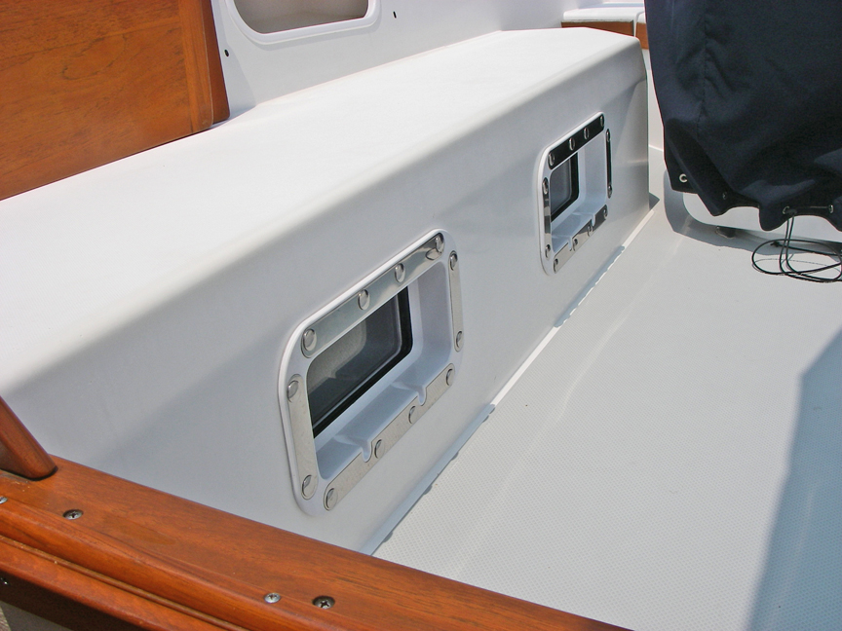 Title- Exterior view of new ports)

Filling and drilling is required to properly fit this port, as it’s not a form/fit replacement, but it’s tolerant of production variance and does not require bedding. This port is held in place with stainless steel machine screws and carriage nuts and utilizes a large replaceable seal on the exterior flange. Most of the port is plastic, with the hardware of 316 stainless and the light clear or tinted tempered glass. Clear glass goes a long way to increasing the ambient light level in the rear cabin. The dogs are designed to allow the port to be cracked open if it’s raining, but when fully released, springs open and hold the port in the open position.

To remove the old ports, I built an inexpensive puller assembly according the instructions published by Stu Jackson in an earlier Mainsheet Tech article. The dimension of the basic cut-out for the Tri-Matrix port is identical to the old 5 x 12 Beckson light, although the rain gutters are different. After removing the old ports, I cleaned off the old bedding material and filled the old drain cut-outs and bolt holes with thickened epoxy. A very thick bondo-like consistency will allow most of the filling of holes and void between the liner and the seat/coachroof with a putty knife, minimizing the amount of sanding required. As a technique when filling, I like to work from the inside out and place masking tape on the exterior of the hole that I’m filling. This eliminates the need to sand the exterior gelcoat surface. As a side note, our 1988 Hull #563, has a tan gel coat liner that is an identical match to SEM ‘Phantom White’ spray paint, a high quality paint designed for flexible surfaces available at automotive paint supply outlets.

After the epoxy cures and is sanded flush, file the cut outs for the new rain gutters and clamp the port in place to provide a guide for the new hole pattern. The New Found Metals website contains extensive illustrated instructions on how to install the ports, including rental of a drill jig that may be clamped in place to simplify installation. Each of our Catalina 34’s is slightly different in dimension and the thickness of the liner/seat assembly which varies over the height of the port. The port is designed to accommodate varying thickness, but if a screw is too long, it will bottom out in the carriage nut before adequate pressure is applied to the seal. New Found Metals offer varied lengths of screws to ensure that adequate pressure is maintained around the flange for a proper seal. Their website explains how to estimate cabin thickness and determine the length of screws needed when you purchase your ports. Since our cabin thickness varied, we had to use two different lengths of screws to achieve a proper seal. The folks at New Found Metals were very helpful and shipped us the right hardware with just a cell-phone call from the boat. If you look carefully at the flange in the second photo, you can see that in our boat, the cabin wall is thicker at the top of the aft port than it is at the bottom. The dogs and hinges are easily adjustable to ensure a good seal of the light when it’s closed.

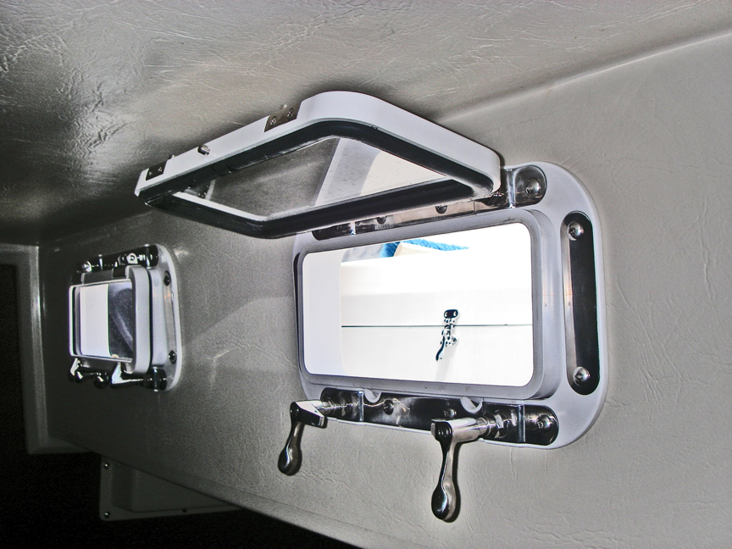 Title- Interior port view

If your 15+ year-old Beckson ports are crazed and beginning to show their age, you might want to consider the Tri-Matrix as a replacement. They will require some filling, filing and drilling to fit, but the new ports look great, eliminate plastic light crazing, and seal well without the hassle of bedding-which will certainly make the next round of replacement or maintenance that much easier.

-Mike Vaccaro, ‘Spirit,’ 1988 Hull 563

